Budget
Will finally be signed. A “balanced budget” as required.
Local Plan
After 8 years, a mountain of work, consultation the plan is “made sound” and will be signed of by all 3 partners by end of this month.
Budget
Finalised and “balanced”
2 Councils with 1 team
Further heating savings
Working well
SNDC town and Parish meetings
Growing and full of up-to-date information. Attend?
The last meeting covered:
The SNDC Strategic Plan
Help Hub Outreach Van
Taking the Help Hub out to residents. Will alert you when in your area.
District Direct
District Direct is a South Norfolk Council service provided across the entire catchment area of the NNUH. It focuses on expediting discharge from hospital and preventing unnecessary admissions. The provision ensures that South Norfolk and Broadland residents are availed of the greatest opportunity to gain and maintain independence.
This service ensures that people do not remain in hospital any longer than they have to, and that social and environmental issues do not result in unnecessary, distressing and disruptive hospital admissions.
Pride in Place grants.
All of these have a positive message and help for PCs and residents.
Election for PCC on 2nd May
Do you have the right ID?
First past the post this time
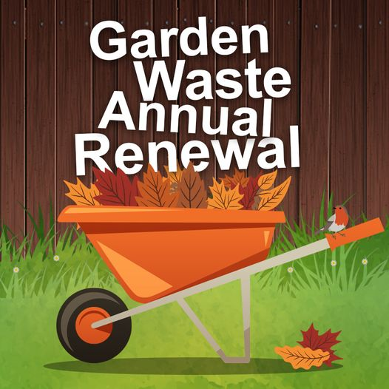
·
Garden waste service invoices will be hitting doorsteps between 4-7 March. If you haven’t received yours by 11 March please email us at wasteadmin.snc@southnorfolkandbroadland.gov.uk or give us a call on 01508 533830.
This grant is open for residents in the South Norfolk district who wish to implement a Play Street.

What are play streets?
Play streets (or ‘playing out’ sessions) are neighbour-led, short, road closures, creating a safe space for children to play freely together on their doorstep. Any street is eligible provided it is not on an active bus route.
Play streets typically allow children to play freely, without organised games or activities. In practice, this means children cycle, scoot, skate, chalk, skip, hopscotch, kick a ball around and make up games.
This model was first developed by parents on one street in Bristol in 2009 and has now been taken up by hundreds of street communities all over the UK.
The key features of this model are:
- Resident-led and organised
- Short, regular road closures
- Free, child-led play
- All neighbours consulted and included
- Road legally and safely closed to through traffic
- Stewarded by residents
- Car access at walking pace
- Simple, ‘normal’ – not a street party!
For further information and advice please visit Play Streets.
To apply for a Road Closure this should be done via Norfolk County Council.
To support communities in taking part in the Play Streets initiative we are offering a Play streets Grant to help with additional costs.

What is the Play Streets Grant?
The grant offers up to £75 to communities who wish to take part in the Play Streets initiative. This may be used to fund:
- Low-cost items such as games and sports equipment for children and families to use during the play streets session.
- Any promotional activities to get the event up and running.
For further information and to apply for this grant please visit our website here.

