The Link
Your spring issue of The Link is out now! Check out our Business Award winners, the amazing work of our Help Hub, where to access free family drop-in sessions and much more. Read it now at http://ow.ly/PyGx50NhJB7 #EmpoweringCommunities
https://twitter.com/i/status/1635664607489531905
The savings made by moving to Broadland and freezing council tax.
The road to carbon Neutral, SNDC leading the way to carbon neutral.
Still helping residents in difficult times.
Schemes to provide mitigation against Nutrient neutrality and start house building.
New projects foe cycleways and new country parks.
The handy person Scheme based in our help Hub.
ID required at may Election.
From May 2023 you will be required to show an official form of photographic identification (ID) when you vote in person at a polling station, a list of acceptable ID documents is included below. If you do not have any of the accepted forms of ID you will be able to apply online for a free Voter Authority Certificate – this is a photographic identity document specifically for the purpose of voting.
If you own an accepted form of photographic ID but it has expired it can still be used, as long as the photograph is still a good likeness of you.
The application service for Voter Authority Certificates is expected go live mid January 2023, please check our website for updates and information on how you can apply. If you need to apply for a Voter Authority Certificate, make sure you do so in good time ahead of it being required at the polling station.
Acceptable forms of ID will include:
- a passport issued by the UK, any of the Channel Islands, the Isle of Man, a British Overseas Territory, an EEA state or a Commonwealth country
- a driving licence issued by the UK, any of the Channel Islands, the Isle of Man or an EEA state
- a biometric immigration document
- an identity card bearing the Proof of Age Standards Scheme hologram (a PASS card)
- Ministry of Defence Form 90 (Defence Identity Card)
- a Blue Badge
- a national identity card issued by an EEA state
- an Older Person’s Bus Pass
- a Disabled Person’s Bus Pass
- an Oyster 60+ Card
- a Freedom Pass
- a Scottish National Entitlement Card issued in Scotland
- a 60 and Over Welsh Concessionary Travel Card issued in Wales
- a Disabled Person’s Welsh Concessionary Travel Card issued in Wales
- a Senior SmartPass issued in Northern Ireland
- a Registered Blind SmartPass or Blind Person’s SmartPass issued in Northern Ireland
- a War Disablement SmartPass or War Disabled SmartPass issued in Northern Ireland
- a 60+ SmartPass issued in Northern Ireland
- a Half Fare SmartPass issued in Northern Ireland
- an Electoral Identity Card issued in Northern Ireland

Postal voting does not need a photo ID
If you use a postal vote you do not need a photo ID. If you are currently using postal vote then you carry on as normal. If don't currently have a postal vote and you are registered to vote in an election or referendum, you may be able to vote by post. A postal vote counts the same as a vote in person and is subject to the same security and secrecy provisions.
You do not automatically get a postal vote even if you are correctly registered for an election or referendum. If you do not already have a postal vote, you have to request one. You do not have to ask for a postal vote just for a particular election or referendum but can have it for all subsequent ones.
Please apply for a postal vote well before Election Day to request a postal vote as you will need to receive, complete and return a postal vote application form.
We mail out the postal votes about 2 weeks before Election Day and we include a prepaid envelope for their return to our offices. Don't forget to return your postal vote before Election Day, or it will not be counted.
Full details of how postal votes work, and the rules governing them are provided by the Electoral Commission.
Application forms for postal voting are available from the GOV.UK website.
The form needs to be printed and completed by hand. We accept scanned versions, these can be emailed to elections@southnorfolkandbroadland.gov.uk. Alternatively please send paper versions to FAO Electoral Services, Thorpe Lodge, 1 Yarmouth Road, Norwich, NR7 0DU.
Local Policing
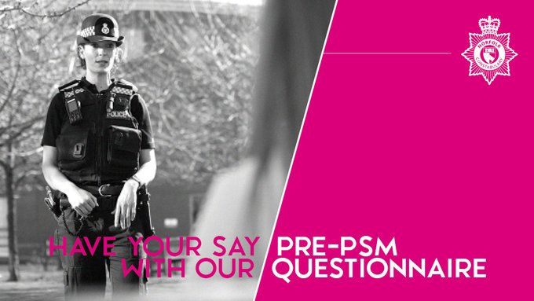
Are you ready for the next round of Priority Setting Meetings? Please try to get at least one member involved.
Find your PSM date and time here: https://norfolk.police.uk/events If you can't come along or would like to share your thoughts before the meeting, please fill in this short survey on your priorities: https://norfolk.police.uk/south-norfolk-policing-your-area-survey
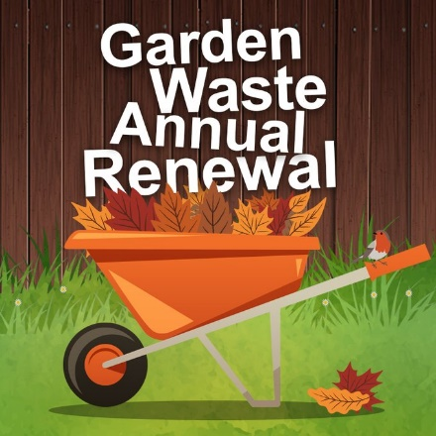

Garden Waste renewal payments are due on 1 April. Please make sure your payment reaches us by this time. Pay online at: http://ow.ly/23E650MY74l. Set up a Direct Debit by 16 March to ensure you never miss a payment. Set up online at: https://forms.southnorfolkandbroadland.gov.uk/pub/DirectDebit.ofml…
Septic Tanks
Do you still have a septic tank, or know someone using a septic tank???????????
We are exploring a scheme to replace septic tanks with packaged treatment plants.
If you do, then please contact me on vic.thomson@southnorfolkandbroadland.gov.uk

