DISTRICT COUNCILLOR REPORT
Covid
Norfolk is still experiencing increases in #COVID infection rates. Let’s continue to make choices that help keep ourselves and others safe.

Water safety
Water Safety: It has already been a busy season for water rescues this year. With visitors and residents hitting the waterways this summer instead of going abroad, the service will be conducting public safety awareness sessions. The first is on Friday (30) at Bawsey Country Park, where sadly there have been four water deaths in the last decade. NFRS will be educating the public in how to use throwlines, what to do if they find themselves in trouble, including the ‘Float to Live’ advice and will also be continuing sessions to train waterside business staff across Norfolk in lifesaving techniques. They are joined by various partners from the Drowning Prevention Forum at the events, including the police’s Broads Beat and RNLI. Last year our service attended 58 water rescues (not including flooding) and there were 9 water fatalities in Norfolk. You can read more about their summer safety work here: Fire service hosts water safety events
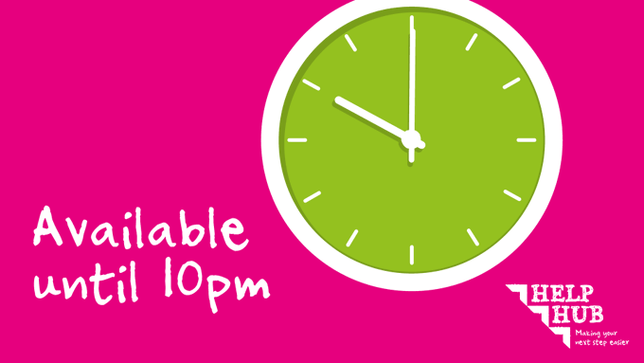
Our Help Hub phone lines are available from 8.15am to 10pm Monday to Friday so you can get advice and support when you need it. Call us on 01508 533933 Find out more about how the Help Hub can support you http://ow.ly/xTE750F7x8Z #WeCanHelp #HelpHub

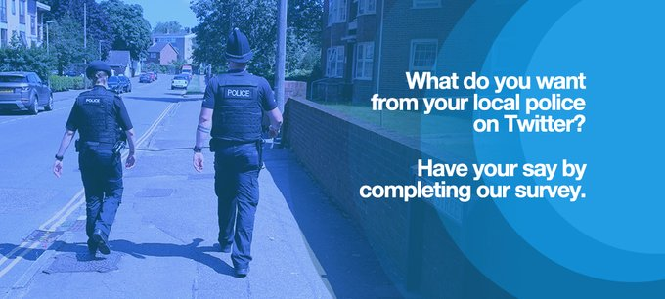
What do you want to see from us on Twitter? Please fill in this national survey to help shape the way we use social media - https://smartsurvey.co.uk/s/Norfolk_Twitter/
Norfolk Fire and Rescue Service: The service is joining a national #KnowExactlyWhere campaign next week to highlight the benefits of using the app What3Words – which helps them to locate emergency incidents quickly and easily. What3Words divides the world up into 3m x 3m squares and if emergency callers are able to give such a location, rescue teams can target resources to the exact spot quickly- particularly helpful with rural incidents. You can watch a short video here about it https://youtu.be/NHEjeUj-IXE Norfolk Fire and Rescue Service would encourage you to download the app and spread the word.
Please don't put batteries in your recycling bin; we have heard of several fires recently caused by batteries! Batteries can be recycled at any of Norfolk's Recycling Centres and many supermarkets or other retails who sell batteries. http://ow.ly/Zp8l50FuMnh

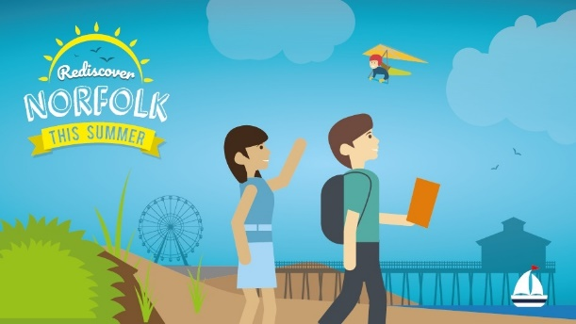
Our Rediscover Norfolk This Summer campaign will help you find the best events, activities and ideas to fill your summer. Fun for all the family!
We’ll be hosting several competitions a week with FREE tickets, vouchers and experiences for Norfolk’s most sought-after attractions! More details on what’s on offer next week..
Give our page a follow to stay up to date and be the first to know when a new competition is up #RediscoverNorfolk
#RediscoverNorfolk with Norfolk Trails tried & tested circular walks to explore your local patch – you’ll be amazed at the hidden places you can find on foot: https://orlo.uk/ajTsV
Getting out in nature is one of the most powerful ways to good health and well-being. Start with a small walk or try a longer hike, either way lots of children are totally ready to release their inner wild child! And perhaps you are too?
Hazardous Waste
We don’t normally take these items at our recycling centres, however we hold annual free household hazardous waste days (amnesties) when we do accept certain hazardous waste items.
These are for residents disposing of household hazardous waste only and not for any business, group or other organisation.
The next household hazardous waste days will take place in September and October 2021:
- 15, 16 and 17 October - Ketteringham
- 23 and 24 October - Norwich North (New recycling centre, due to open later this year.)

